<<COURT_NAME>>

|  |  |
| --- | --- |
| <<PROVIDER_SUITNAME>>,  a/a/o <<INJUREDPARTY_NAME>>    Plaintiff,  vs.  <<INSURANCECOMPANY_SUITNAME>>  Defendant. | Case No. <<INDEXORAAA_NUMBER>> |

__________________________________________/

**NOTICE OF SETTLEMENT**

COMES NOW the undersigned counsel and states that the Parties have reached a global resolution in the instant matter and are in the process of submitting settlement documents to the Court. This Court will retain jurisdiction to enforce same.

**CERTIFICATE OF SERVICE**

I HEREBY CERTIFY that on ­­­­­­­­­­­­­February 19, 2022, a true and correct copy of the foregoing was filed and served on the Defendant through the Florida E-File Portal.

**The Florida Insurance Law Group, LLC**

8724 Sunset Drive, #260, Miami, FL 33173

Tel. (305) 906-4262

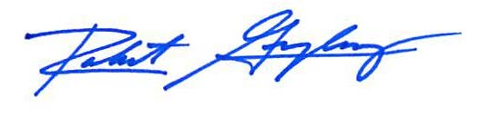

Robert F. Gonzalez, Esq.

Fla. Bar No. 68865

[Pleadings@flinslaw.com](mailto:Pleadings@flinslaw.com)